These flowers are blue, aren’t they?

________________________________________________________
When you go to school, do you like your class?

________________________________________________________
If you see a dog, are you afraid?
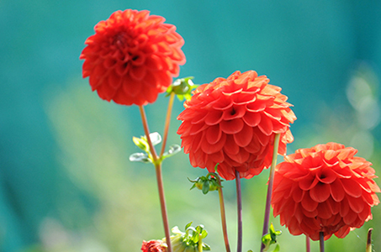

________________________________________________________

What is your decision? Yes or NO ?
Please fill the voids above the lines with your own answers. But just don’t only yes or no me!
Do you like to work in the garden?

________________________________________________________
In case you can’t go on holiday, will you stay in the house?

________________________________________________________
Did you enjoy the last movie you watched?

________________________________________________________
Can you detect any leaves in the tree that you can see on this page?

________________________________________________________
Would you like to climb this tree?

________________________________________________________
The trees are always green, aren’t they?

________________________________________________________
I cannot see any roots, can you?

________________________________________________________
Do you have a favourite tree?

________________________________________________________
If you had your own garden, would you plant a tree?

________________________________________________________
That is all for now, did you enjoy it?
________________________________________________________

I sincerely do hope that you were having fun with the worksheet.

Mister K.Now

